- search a place in school: Customer logins the JagTran system and chooses the function of search place. System presents result on the map.

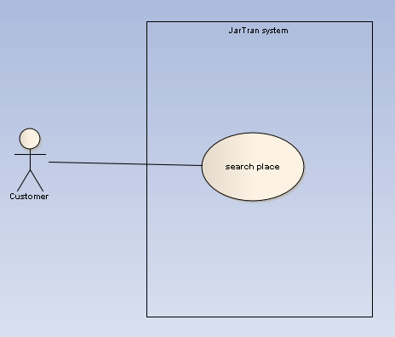

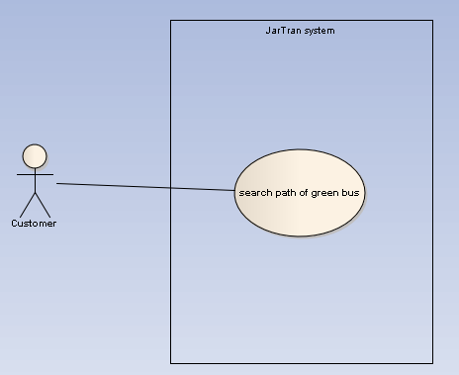
- search the path of green bus: Customer logins the JagTran system and chooses the function of search the path of green bus. System presents result on the map.

